**CloudCraze Table Setup for Controls**

* **CC Storefront ERP**  
  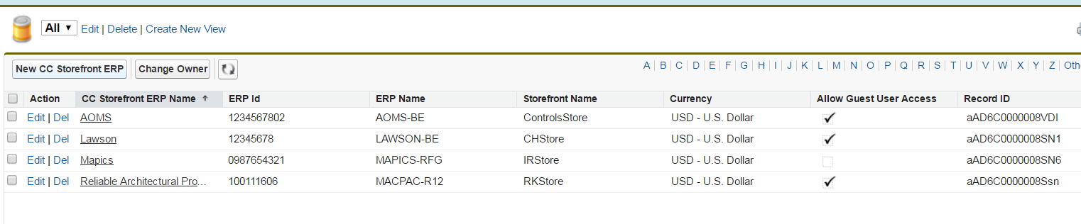
  + - CC Storefront ERP Name: “AOMS”
      * ERP Id: 1234567802?, ERP Name: “AOMS-BE”, Storefront Name: “ControlsStore”
* **Bill To**
  + - Account Load updates this table to link Account to ERP Customer #
      * AR-Number
        + AOMS-BE-11111??????
    - Guest User setup for ControlsStore (new for Controls)
      * Account: CCAnonymous
      * Bill To Name: JCI CO - Guest User Pricing
      * AR Number: AOMS-BE
      * ERP Name: AOMS-BE
      * ERP Account Id: 12345678??
* **CC ERP Number** 
  + Proposed
    - Product Load updates this table to link CC Product to ERP SKU #
    - Link to “CC Storefront ERP Name” i.e. Lawson, Mapics, MacPac, AOMS
* **CC Account Group**
  + No proposed changes
  + Current Records
    - Anonymous
    - Portal Account
* **CC Account Group Price Lists**  
  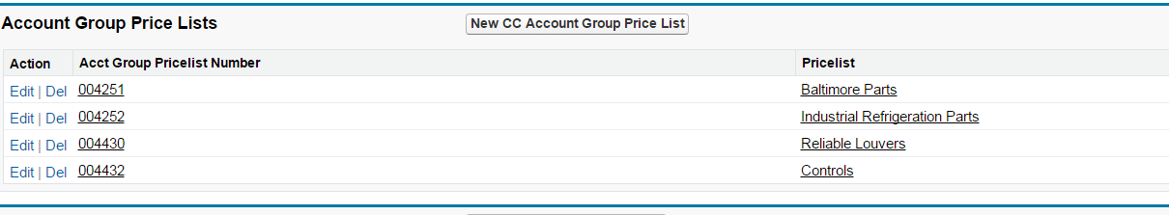
  + - Add 004255 for Portal Account Controls(**Actual- 004432**)
* **CC Price Lists**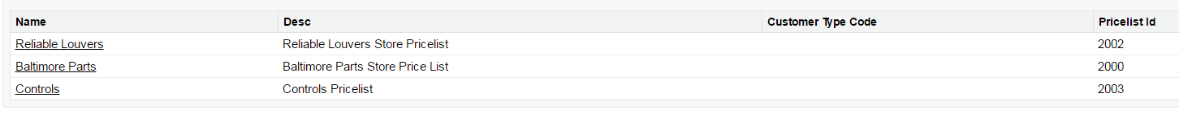
  + - Add 2003 for Controls
* **CC Categories**
  + - Need to define and preload Parent/Child Categories
* **ERP Product Catg Xref**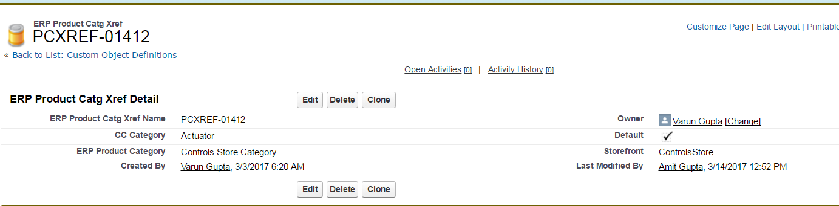
  + Proposed
    - Used to xref inbound products to storefront product categories
    - Must be preloaded before prior to loading or interfacing products
  + Add Storefront Picklist Value ControlsStore and Category name etc.
* **For Categories to be reflected on Cloud craze below steps need to performed:**

|  |  |  |
| --- | --- | --- |
| 1.1 Clone ControlsStore storefront | * Click on CC Admin tab * Click on Storefronts * Click Clone button which is associated with “CHStore” * Enter “ControlsStore” and click clone store. |  |
| 1.2 Change Theme for RK store | * Click View on ControlsStore * Click on Themes * Click Enable for cc_jci_OrdNavControls_Theme |  |
|  |  |  |

## Changed the Root Category Id for that specific storefront.(CC admin - Specific storefront)

## In general settings need to go in Indexing option and refresh Category Tree cache.

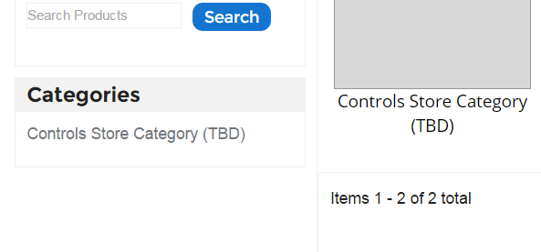

**Manual Steps for Creation of new Storefront(ControlsStore):**

1. First to show storefronts on selection page we need to add our new store in **cc_jci_StorefrontSelection** vf page and also in **cc_jci_ctrl_StorefrontSelection** class.

And after that we need to run below queries to match the records and check storefronts count for a particular user:

select ERP_Name__c from Bill_To__c where Acct__c=:effectiveAccountId

select Storefront_Name__c, ERP_Name__c  from CC_Storefront_ERP__c

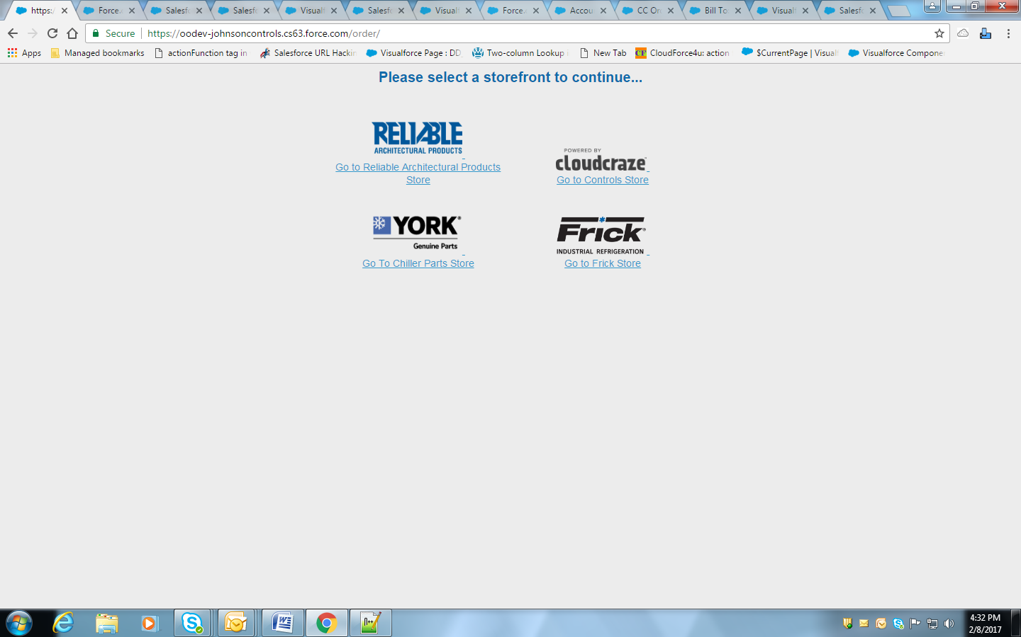

Need to add images for new storefront in Static resources and name it properly in **cc_jci_ctrl_StorefrontSelection** class (e.g **cc_jci_OrdNavControls_Theme**)

In APEX Class:

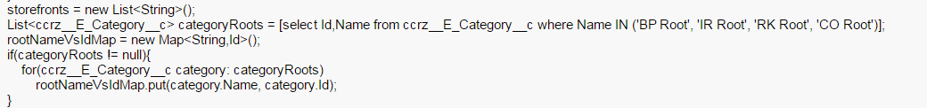

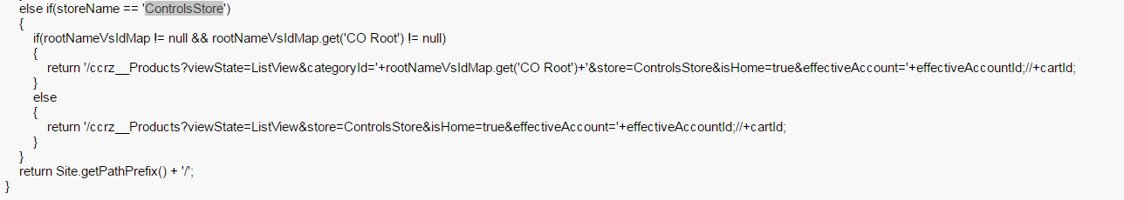

Visualforce: cc_jci_StorefrontSelection

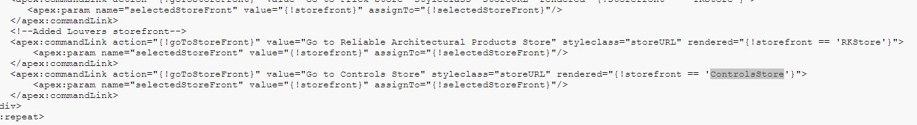

1. Guest User Browsing:

**Enable Guest User checkbox(CC StorefrontERP’s) to get access for Guest storefront page and controller**

**Below are steps:**

**• Click CC Storefront ERP tab**

**• Click Edit for LAWSON record.**

**• Change the Field: Allow Guest User Access to true.**

1. Now, We need to change constructor of **DD_HomeController** classand after that need to create new **cc_jci_Guest_StorefrontSelection** vf page and **cc_jci_ctrl_Guest_StorefrontSelection** class for guest users.

**DD_HomeController:**

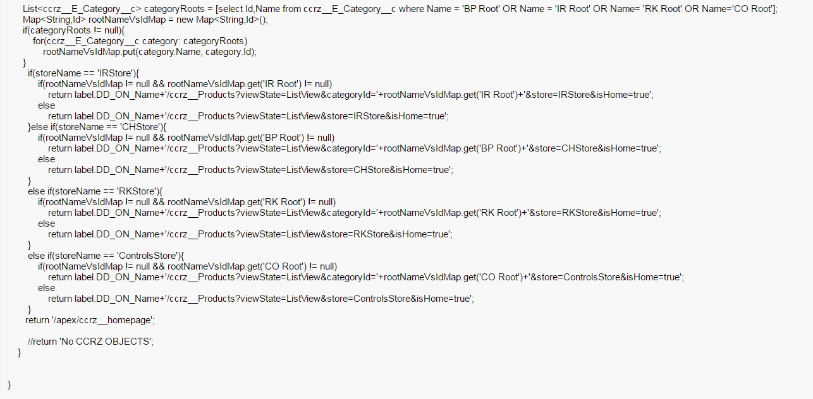

**Visulforce Page: cc_jci_Guest_StorefrontSelection**

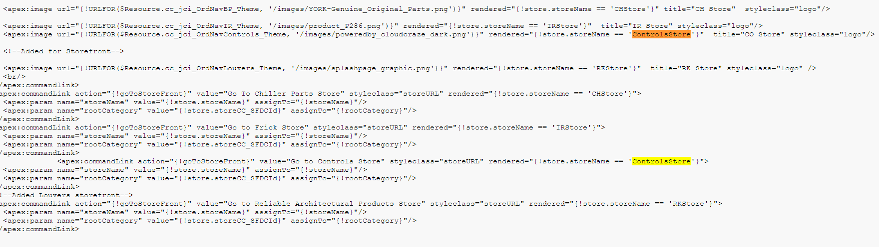

APEX Class: **cc_jci_ctrl_Guest_StorefrontSelection**

**Code is already bulkified and it will get data accordingly.**

1. **For Homepage:**

We have modified the classes and visualforce components corresponding to red highlighted box contents.

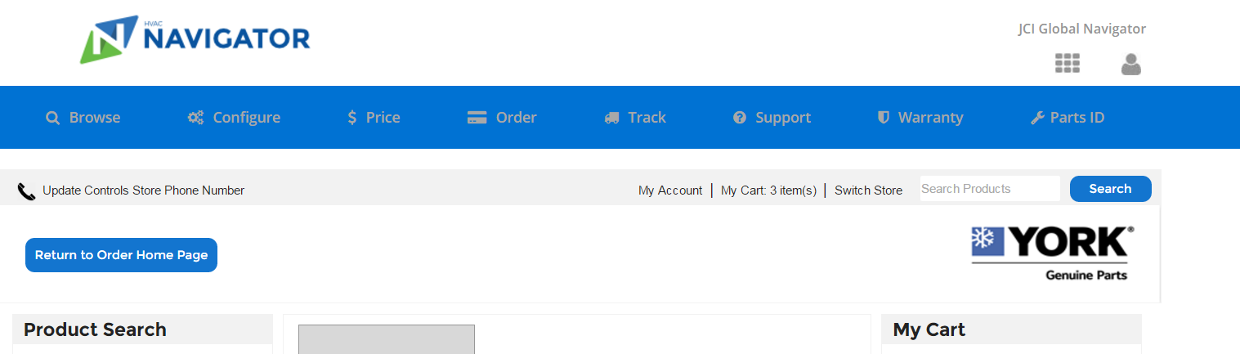

cc_jci_HeaderInclude(VF Component)

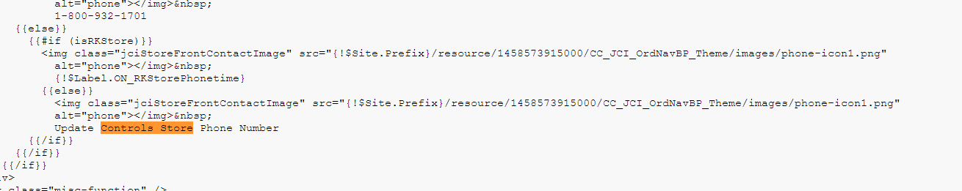

cc_jci_MenuInclude(VF Component)

PENDING

cc_jci_CCHeaderInclude(VF Component)

PENDING

cc_jci_ctrl_MiniCartInclude(Apex class)

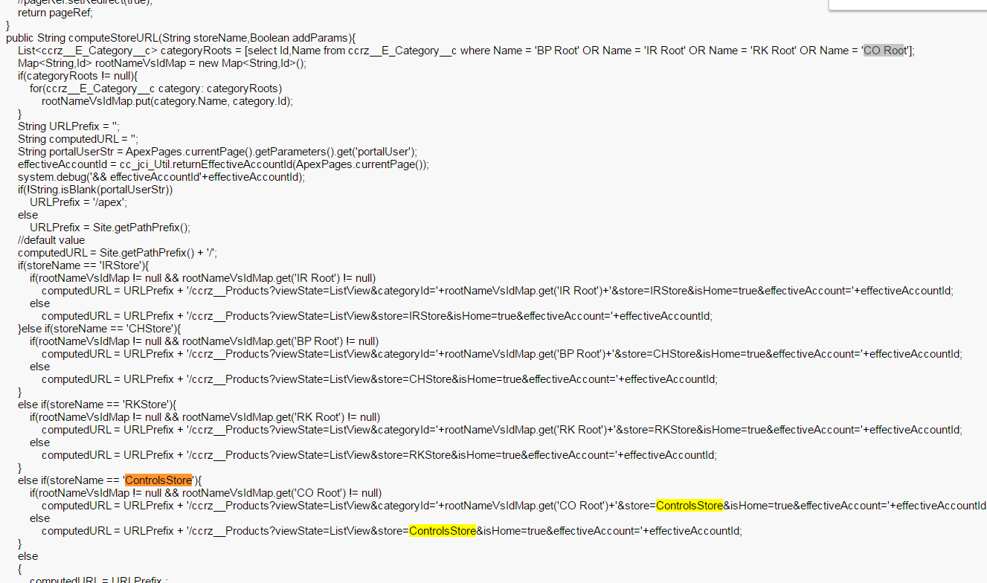

1. **For changing Footer email id for new storefront need to modify cc_jci_FooterInclude vf component.**

**Pending---**

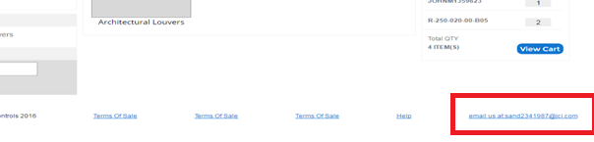

Create custom label for storing footer email id: for example , for RKStore - **ON_LStoreEmail**